Winter Festival at WRES

Monday, February 23 – Friday, February 27, 2026

Schedule of Events...

Monday, February 23   | Crazy Hat or Hair Day – Dig out your craziest, coziest, or favorite hat and wear it to school. Or… style your hair in a fun and crazy way!
Tuesday, February 24   | Jersey Day – Wear your favourite jersey!  School-wide Bingo – Students will each receive a Bingo card and the numbers will be called over the PA system. Prizes for the winners!
Wednesday, February 25  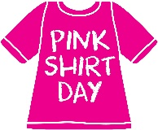 | Pink Shirt Day – Stand up for kindness by wearing your pink shirt today!
Thursday, February 26  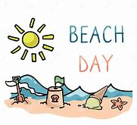 | Beach Day – Dig out your sunny clothes and accessories and wear them to school!  Construction Day – Bring in materials to build with, like empty boxes, Kleenex boxes, paper towel rolls, etc.
Friday, February 27  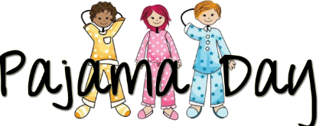 | Pajama Day – Come dressed in your coziest pyjamas!  Pancakes for Breakfast!  Play Day – Students will learn through play all day!

